Nova Retail Performance Analysis Report
Name: ABDULLAH AYUB
Roll NO: BSDSF24M029

Sales Velocity and Core Time Intelligence
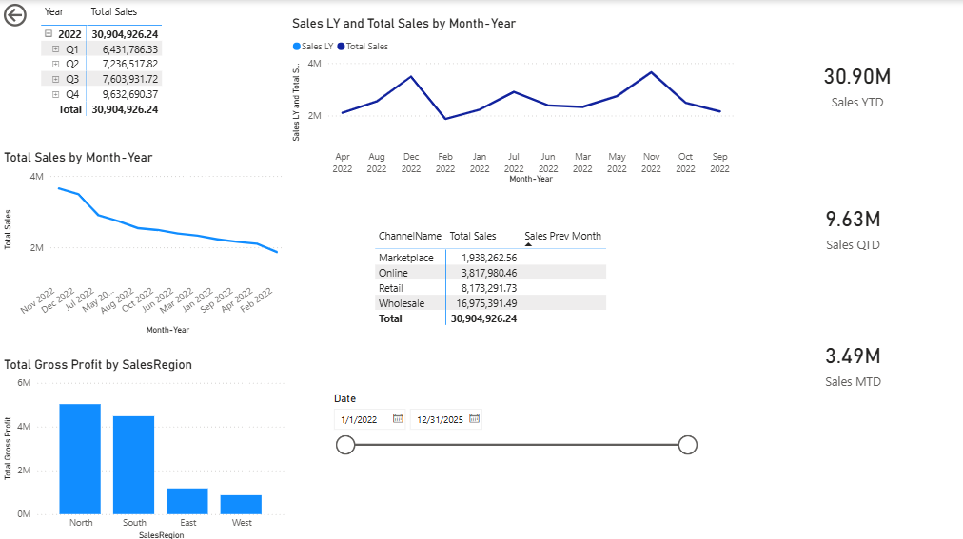

Key Data Points:
- Total Sales Performance: According to the dashboard, the total Sales YTD stands at $30.90M.
- Quarterly & Monthly View: Sales QTD of $9.63M and Sales MTD of $3.49M indicate that the sales momentum remains stable across the current periods.
- Regional Profitability: The bar chart clearly illustrates that the North Region generates the highest Gross Profit, followed by the South Region. Profit margins in the East and West regions are significantly lower.
- Channel Analysis: The Wholesale channel holds the largest share of revenue ($16.97M), while the Marketplace remains the smallest segment in terms of contribution.

Interpretation:
By utilizing time-intelligence measures, we observe that sales peak significantly during the year-end (December). The monthly trend line suggests that the retail business is subject to high seasonal fluctuations, necessitating proactive inventory management for Q4.

Growth Trends and Rolling Calculations:

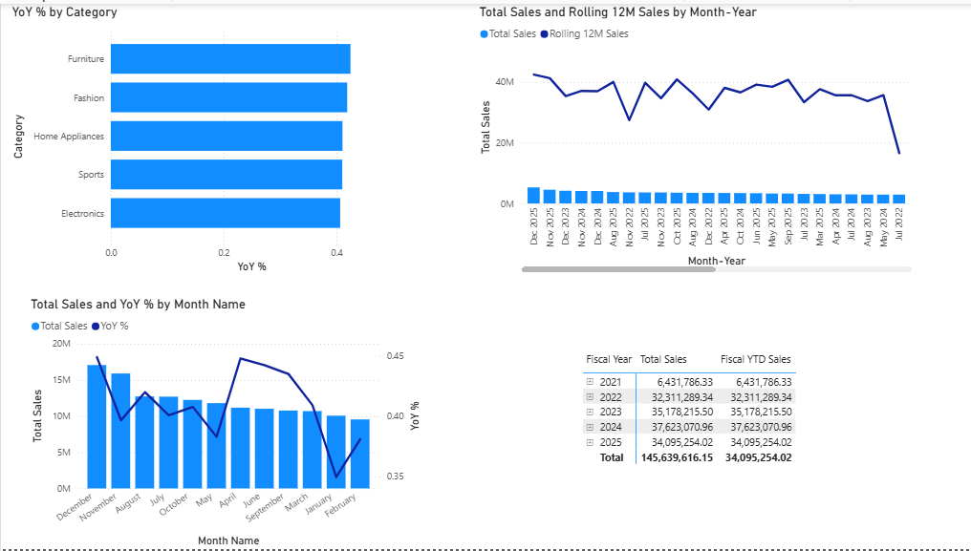

Key Findings:
- YoY Growth by Category: The most impressive growth has been observed in the Furniture and Fashion categories, where the YoY % is approaching approximately 0.4 (40%). In contrast, the Electronics category shows a relatively slower growth rate.
- Rolling 12M Sales: The line chart demonstrates that the "Rolling 12M Sales" is significantly smoother than the volatile monthly sales bars. This confirms a positive long-term growth trend for NovaRetail, despite short-term monthly dips.
- Fiscal Context: The Fiscal Year summary table reveals that while 2024 was a peak year with $37.62M in sales, the 2025 performance currently stands at $34.10M, indicating a need for aggressive strategies to meet year-end targets.

Budget vs Actual and Final Challenges:

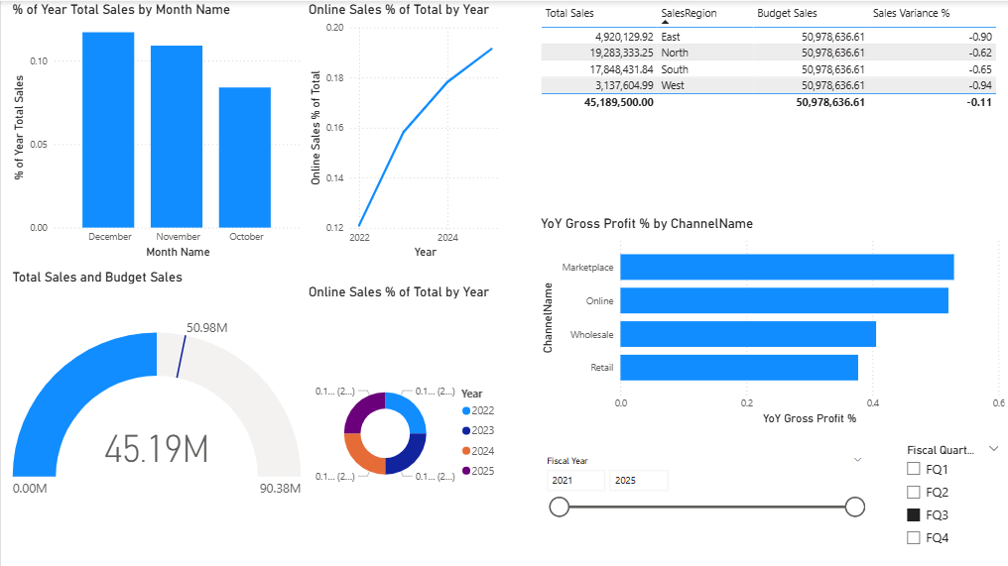

Key Analysis:
- Budget Variance: According to the gauge visual, Actual Sales are $45.19M against a Budget of $50.98M. This represents a total budget shortfall of $5.79M.
- Regional Variance: The treemap visual identifies that the North Region carries the most significant negative budget variance, which serves as a critical "Red Flag" for management.
- Online Channel Growth: Both the line and pie charts confirm that Online Sales % has been steadily increasing from 2022 through 2025, validating the success of the company’s digital transformation.
- Consumer Segment: The comparison between Consumer YTD Sales and Prior YTD Sales shows that current year performance (light blue bars) has consistently outperformed the previous year on a month-by-month basis, particularly in Quarter 4.

Conclusion & Recommendations:

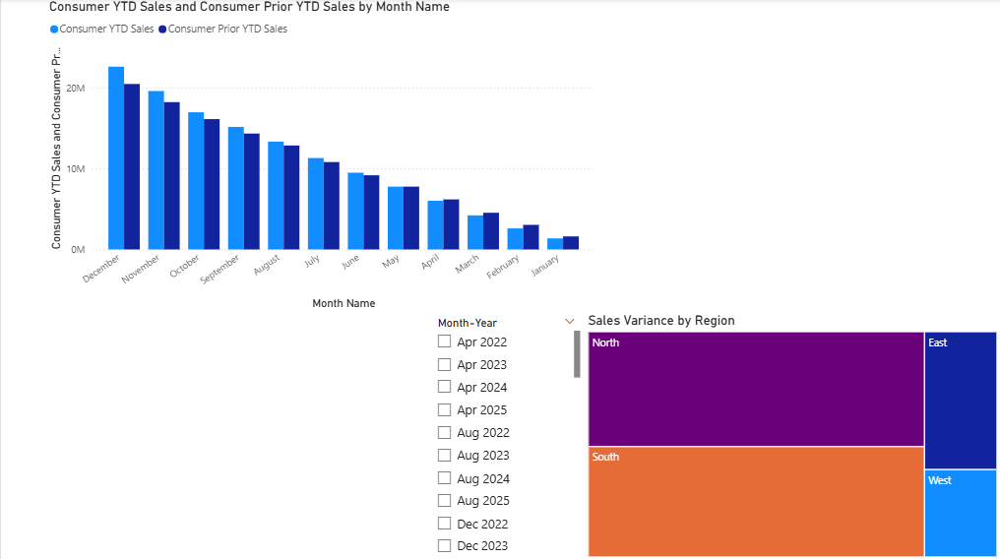

- Focus on North Region: Despite being the top revenue generator, the North Region is failing to meet its specific budget targets. A deep dive into regional sales operations and local market conditions is recommended.
- Category Investment: Furniture and Fashion categories are showing high growth potential. Shifting a larger portion of the marketing budget toward these categories could maximize ROI.
- Digital Transformation: The consistent growth in Online sales suggests a shift in consumer behavior. Optimizing this channel further could reduce the business's heavy dependency on the Wholesale segment.

